**Tugas Praktikum   
Pemrograman Berorientasi Objek**

“Tugas 10 Studi Kasus ATM*”*

**Kelas A**



Oleh :

Muhamad Ihsan Setiawan

4523210069

Dosen :

**Adi Wahyu Pribadi**

**S1 Teknik Informatika**

**Universitas Pancasila**

**2024/2025**

**Program Code**

**Account.java**

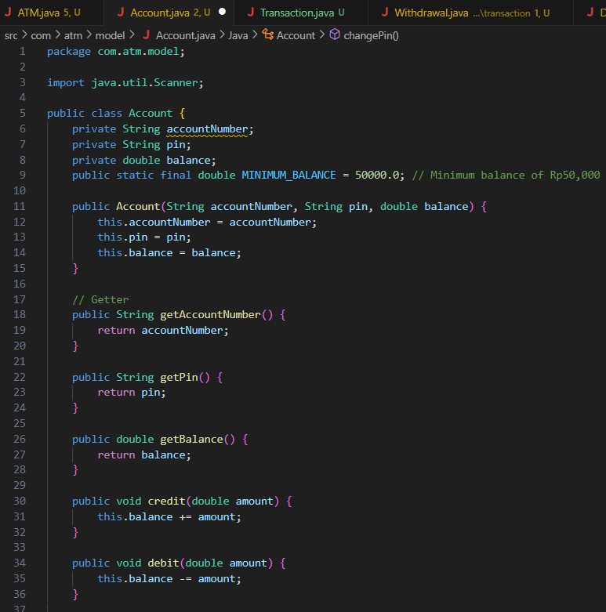

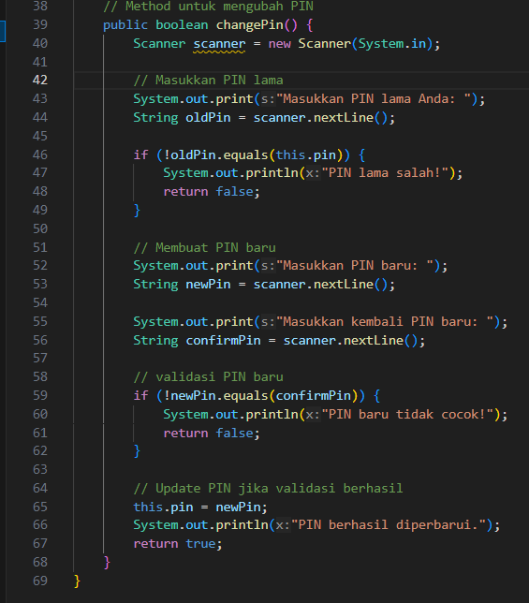

**Deposit.java**

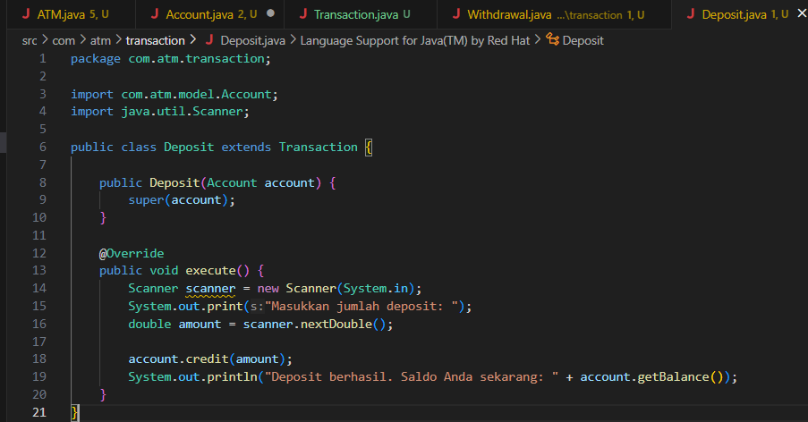

**Transaction.java**

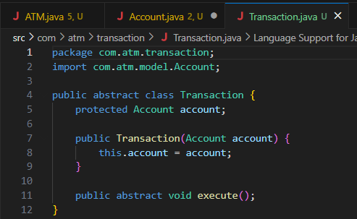

**Transfer.java**

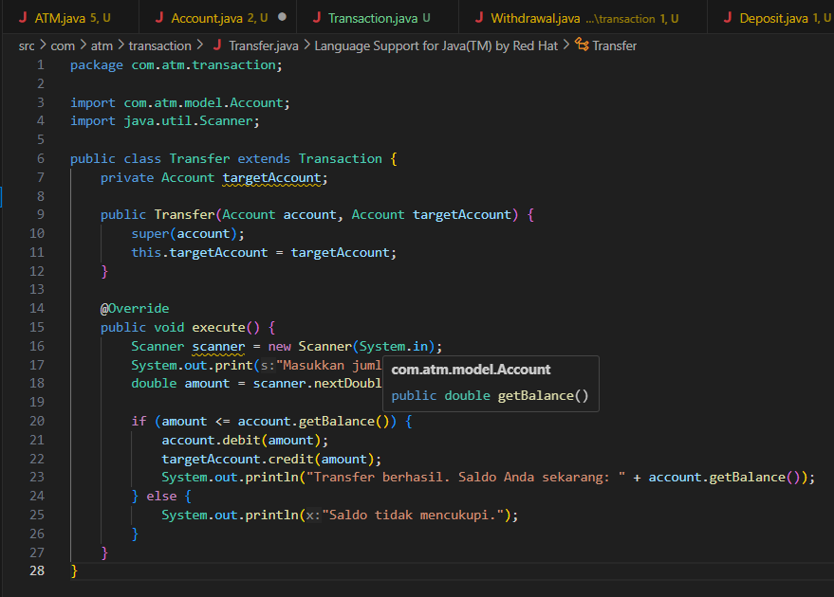

**Withdrawal.java**

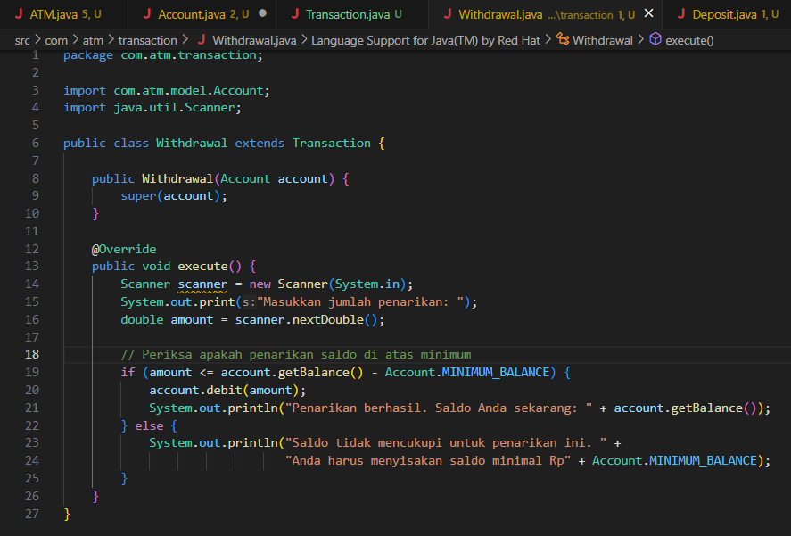

**ATM.java**

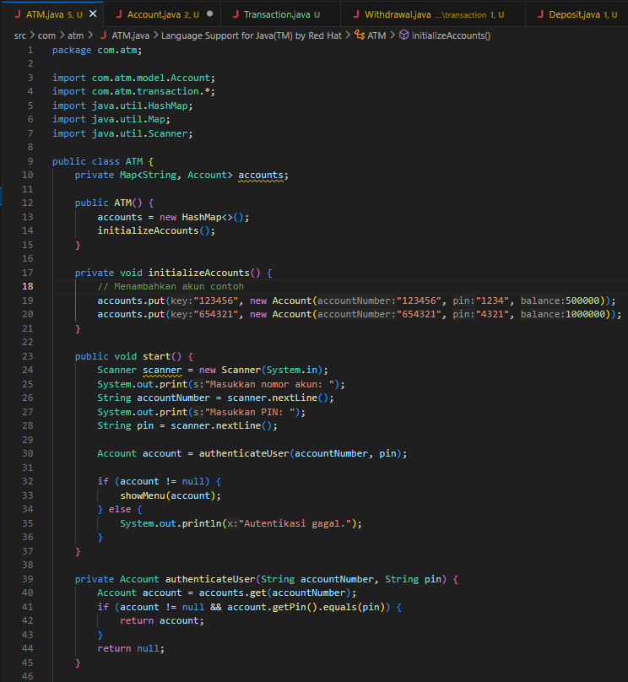

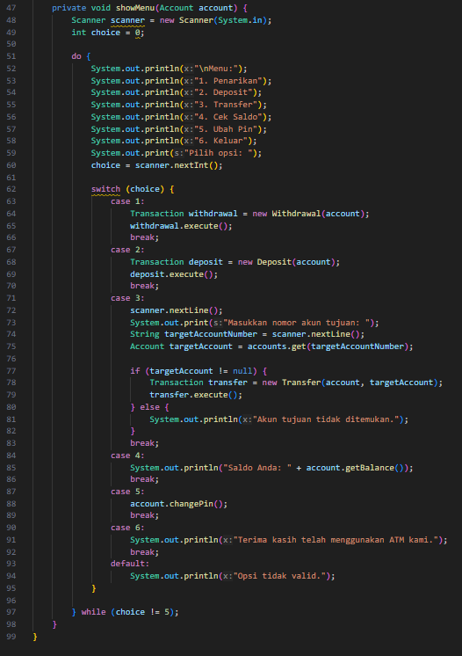

**Main.java**

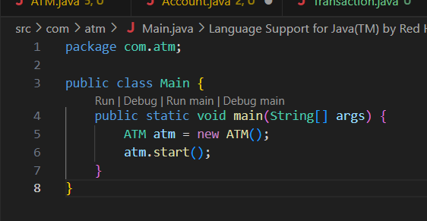

**Hasil Running Progam**

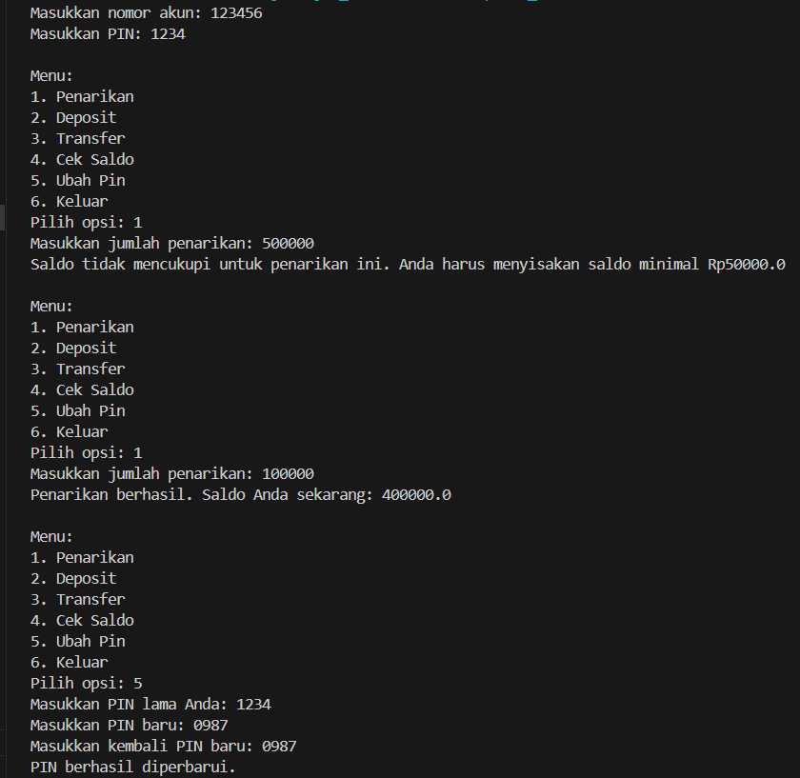

**Link GitHub:** https://github.com/icen6/Tugas-Praktikum-PBO.git